Let X = winnings from a $100 bet on black

* What is the probability distribution of X?
* What is the expected value?
* Variance Var(X)=
* **Transforming random variables**
* Imagine you have to pay a $5 fee to play. What is the probability distribution now?
* Find the expected value of playing this game.
* Find the variance and standard deviation for this game.
* Multiplying a random variable by a constant

µ:

$σ$:

$σ^{2}$:

**Homework 2:**

1. A small ferry runs every half hour from one side of a large river to the other. The probability distribution for the random variable Y = money collected on a randomly selected ferry trip is shown here. We have known μY=$19.35. Calculate and interpret the standard deviation of Y.



2. Fundraising by telephone Tree diagrams can organize problems having more than two stages. The figure shows probabilities for a charity calling potential donors by telephone. Each person called is either a recent donor, a past donor, or a new prospect. At the next stage, the person called either does or does not pledge to contribute, with conditional probabilities that depend on the donor class to which the person belongs. Finally, those who make a pledge either do or don’t actually make a contribution. Suppose we randomly select a person who is called by the charity.

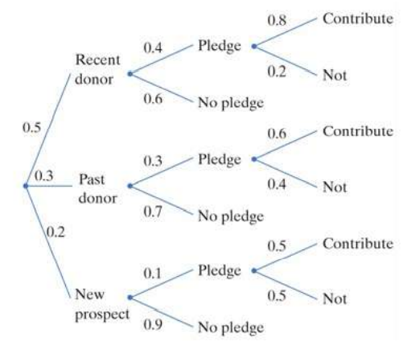

1. What is the probability that the person contributed to the charity?
2. Given that the person contributed, find the probability that he or she is a recent donor